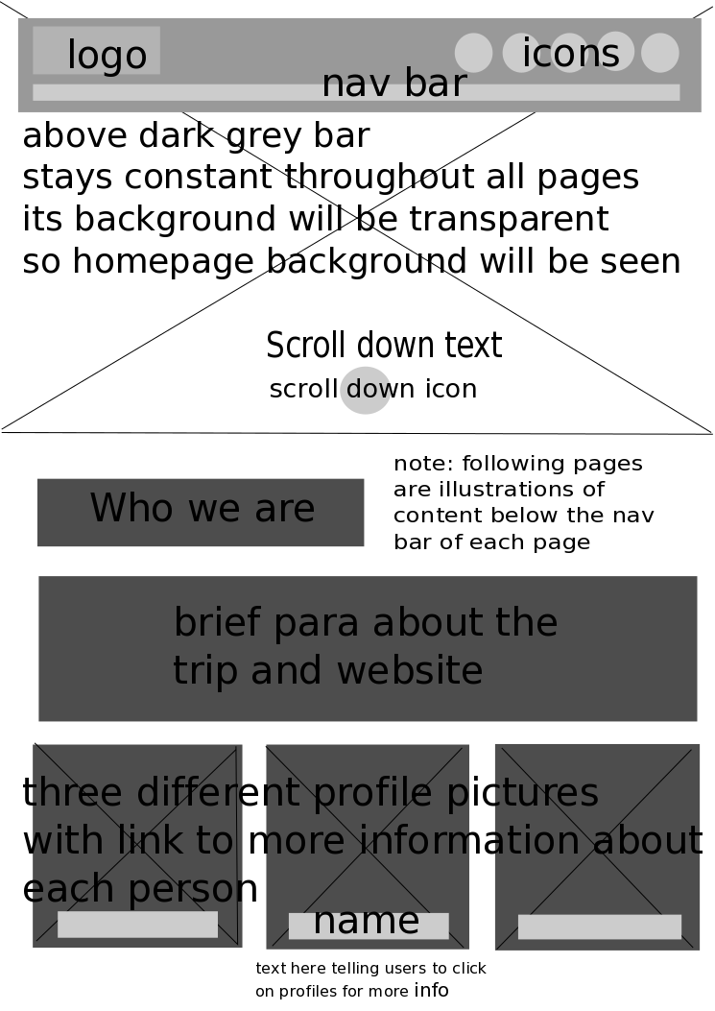

|  |
| --- |
| Not sure we’ll have a logo as it’s more like a collaboration of artists, makes more sense if we call it title? (rectified)  Icons are a good idea: are they facebook, twitter etc? If so, maybe we need individual ones which make it clear which of us they’re linking to, maybe on the individual sections? (Flo, Lara, Marta) (has been changed such that contacts will not appear here but on individual sections)  Does the link behind the profile picture take us to that person’s page and work? Yup! It will lead the user to the profile (template can be seen in next page) the user clicks on. |

|  |
| --- |
| Option 1  How does the location filter work? I don’t mean technically but in practical terms, is it a dropdown menu? Does it change which items are on display? The location filter will be dropdown menu listing all the different places the person has travelled to and the images/videos on display will change accordingly. So the list could state: all, location X, location Y etc. and the images displayed could either be all (starting from earliest pictures to latest pictures or vice versa), pictures only from location X or pictures only from location Y respectively.  Does the picture and its details below change depending on which you click on in the gallery? Yup so the title of the picture and the image description will correspond directly with the image selected or whatever image the user scrolls to. Images available in the gallery below will correspond with the filter in the previous page as well. |

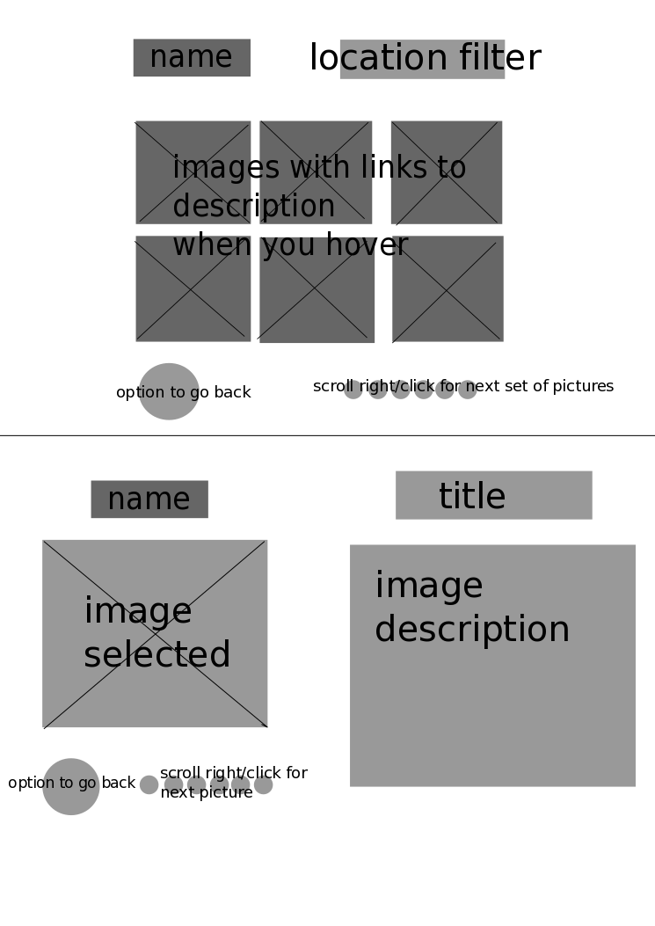

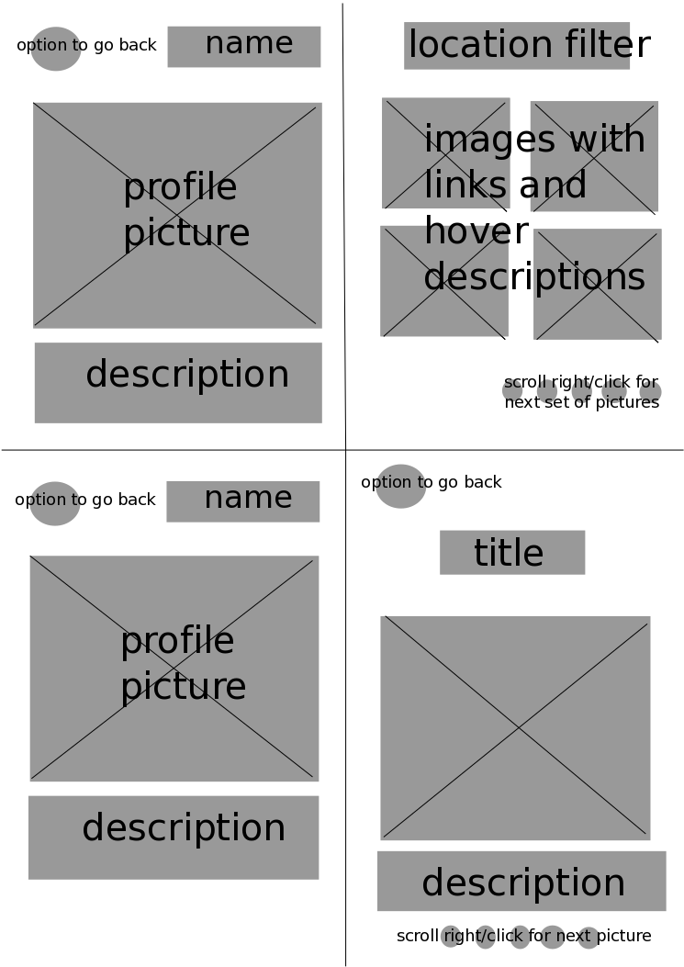

|  |
| --- |
| Would the ‘go back’ button take to home page? Should there be navigation to the map and other profiles too? The nav bar and title (as shown in the first page/ the dark grey rectangle) will be constant throughout all pages. So these pages are simply an illustration of the bottom half of what the page will look like. The go back button will lead to the ‘who we are’ page where the user can select other profiles but let me know if you would rather prefer the nav bar (which again is constant throughout) to have three button icons for the three profiles.  I like the split screen. I think the profile pictures can be smaller here if we have big hero pictures on the home page. I suggest that I can do a name and profile picture side by side thing and widen the description bit.  Does the section on the right relate to the profile on the left? How do the two sections on the right, top and bottom relate to each other? Does the top one become the bottom one when you click on an image? So how it works is that you start with the top half which is a split page with one profile column with one gallery column. Clicking on one image will lead you to the bottom half where again it’s a split page with one profile column and one image/description column with scroll option. |

|  |
| --- |
| I like the idea of having the map show where we are but I think it’s more likely to be updated once the trip is finished. I suggest then making different markings for the three individuals and then providing links to works. If the images are not there then the page will state that the individual hasn’t been there yet.  Good call including a legend to explain what’s going on and how to navigate the map.  I think the contact section should actually be discreet social media icons at the bottom of each profile.  I like the comments section, maybe it can come after a timeline/mini-blog section where we enter a story/description of what we got up to at each location? How bout we just change this to blog where all of you can post individual stories and stuff  Just wondering if navigation needs to be more obvious throughout the site so that people know what they can find and call to action on homepage (or any page) can be to visit the profiles or map or timeline of our trip.  Also, should these be separate pages or a scroll down through all these sections? Idk, maybe it would take too long to load all the images and map etc? |

